South Delta Secondary 2019/2020 Mrs. Reimer

Creative Writing 11/12 Course Outline

Phone: 604-943-7407

Email: kjreimer@deltasd.bc.ca (general contact)
reimersdss@gmail.com (assignment submissions)

Web Page: reimersdss.weebly.com

Course Focus
The focus of Creative Writing 11/12 is to encourage students to:
- Communicate effectively in written, spoken and visual forms
- Develop confidence and refine writing skills for various creative purposes
- Explore personal & cultural identities, memories, and stories in a wide range of
genres
- Collaborate and strengthen skills through writing and design processes
- Think critically, analytically, interpretively, creatively, and reflectively

Learning Outcomes
Creative Writing 11/12 is grounded in the exploration and application of writing processes, inviting students to express themselves creatively as they reflect on, adjust, and extend their writing skills. As creative writers, students will be asked to be observant of the world around them, take risks and challenge themselves while writing for authentic audiences and real-world purposes. They will explore texts and stories to understand their purpose and construction, as well as understand how language shapes ideas and influences others.

Course Content
- Each of the three terms will be guided by an over-arching theme. These themes may be treated independently or overlap. The theme for first term will be chosen by the teacher, second term students will have a selection of themes to choose from, third term will be individual choice.
- Each term will have three areas of focus: Poetry, Fiction, and Non-Fiction, from which the focus of study will be narrowed to specific forms or genres. We will also focus on the conventions of writing & language, and building vocabulary.
- As storytelling, whatever the form, is steeped in the oral tradition, there will be an element of public speaking involved in the course. Students are expected to participate in class discussion, share their work through the peer editing process, and present pieces orally to their classmates.
- Over the course of the year students will keep a portfolio of the writing they have accomplished. The portfolio will be submitted periodically throughout each term for assessment, furthermore, it will act as the summative submission at the end of each term. While the portfolio is a significant part of each term’s assessment, more emphasis will be placed on the formative assessment of the writing process (brainstorming, drafting, proof reading, and editing).

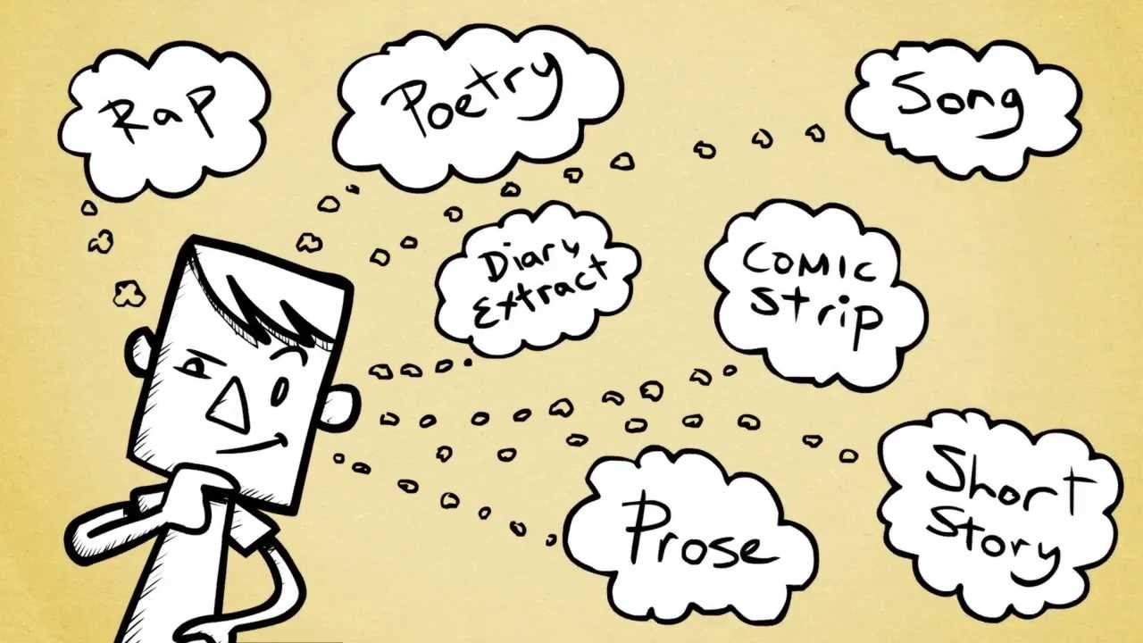

Class Expectations

Keep an open-mind and a positive attitude. As the old saying goes, “Minds, like parachutes, only work when they are open”.

Classroom Procedures:
- You must arrive to class on time and fully prepared.
- On time means being at your desk, in the classroom, prepared to work when the bell rings.
- Fully prepared means having 2 working pens of different colour, highlighter, paper, post-it notes, your binder, and any course texts

The objective is to have a classroom where there is a minimum of posted rules and a maximum of respect for others, including your classmates and your teacher. This means that the individual student is responsible for their own actions. It also means that the student must listen and behave towards others in the class in a manner that demonstrates respect for themselves and others.
Attendance/Absences:
- Regular attendance is absolutely necessary. To learn, you must be here!
- Students are responsible for catching up work they have missed due to an excused absence. See your teacher about missed work so that you can complete it and be ready for the next class.
- If you are absent on the day of a test or the day an assignment is due, be prepared to write the test or hand in the assignment on the first day you return to school.
- If you expect to be absent for an extended period of time, please contact your teacher to make arrangements to complete work, make up tests, and set suitable due dates.

Assignments:
- One of the most important things that you can do to maximize your chances of success is to develop good work habits. You will have homework regularly. Even if you do not have any “written” homework, you are expected to review at home the work you do in class each day.
- Incomplete or messy assignments will not be accepted.
- Students who submit plagiarized assignments will receive a mark of ZERO, their parents will be contacted and they will be referred to the administration.

Extra Help:
- I will be available on day two before school (8:00-8:30) or after school until 4:00. If you need to see me it would be best if you try and make an appointment with me to ensure that I will be there to answer your questions.
- Don’t wait until I am checking your homework or collecting an assignment to tell me you had problems with it or didn’t understand it. I will be more likely to help you, or work out an alternate plan with you, if you approach me before the deadline. A good way to get a hold of me is through email, although I am available most lunch breaks, and especially during Flex!

